Voice Acting Information for :

**Kerlih Chia**

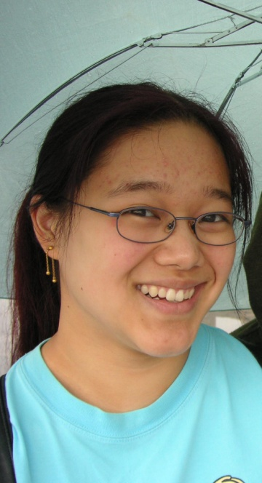

E-mail : [chiak3@gmail.com](mailto:chiak3@gmail.com)

Location : Vancouver, B.C, Canada

Website: <http://voice123.com/kerlihchia>

Experience:

|  |  |  |
| --- | --- | --- |
| Shadow Conclave | Shanna Rat | Hugo Damas |
| Elliptical Diffusion (trailer) | Narrator & Rogue | White Circle Studios |
| That Spider Guy | Walla - various | Callan Bencich |

Bio: Kerlih began her voice-over career attending an Introduction to Voice Over workshop at Soundwrites in Vancouver. Beforehand, she has obtained B.A in Film Studies at the University of Alberta, and later received her Film & Digital Arts diploma from Pacific Audio Visual Institute. Currently, Kerlih looks to gain more experience as a voice actor: auditioning for independent projects and looking towards acting courses.

Feel free to contact Kerlih Chia regarding voice acting for your projects!